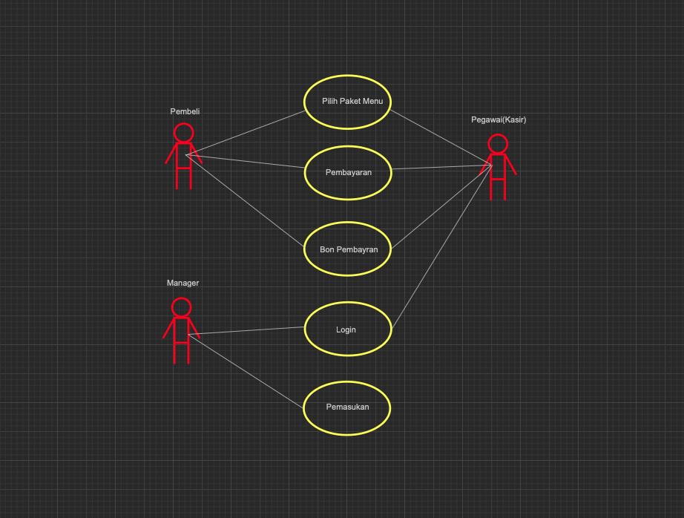

**Use Case Diagram Restorant**

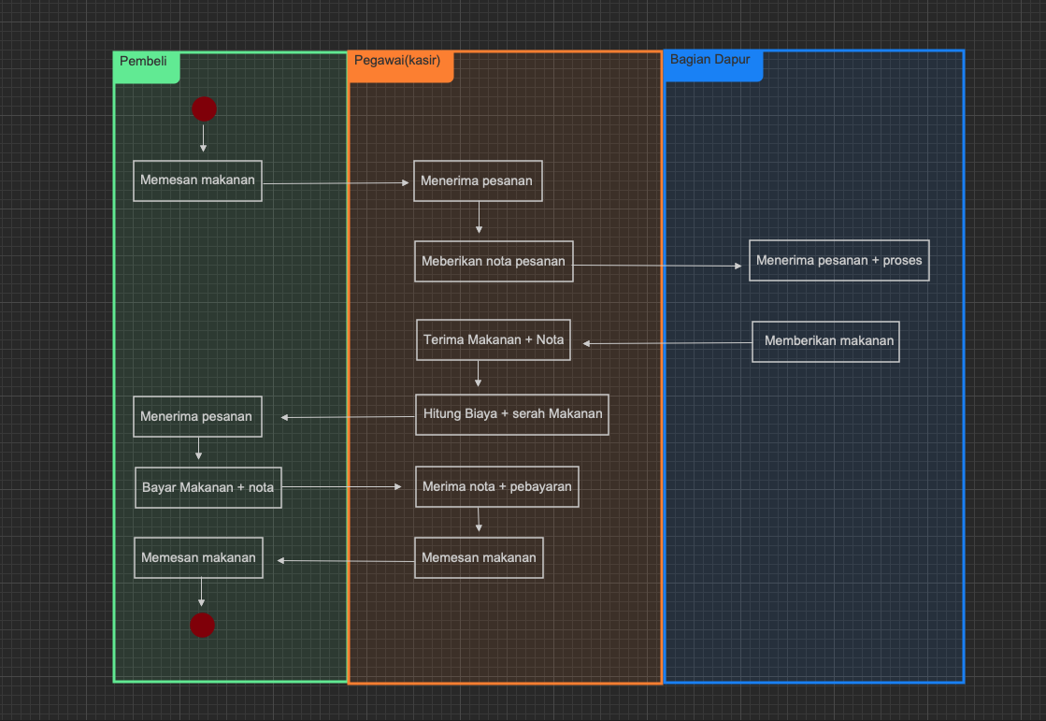

**Activity Diagram Restorant**